# Appendix 3. Synthetic Catalog for Background Seismicity (during the pre-mainshock stage)

To assess the mainshock's impact on earthquake distribution, the current seismicity distribution was compared to the background seismicity. However, directly using observed records prior to the mainshock could introduce bias due to sampling errors from limited time windows and spatial domains. To address this, a synthetic catalogue of 10,000 events was generated based on the spatial distribution of observed seismicity during the pre-mainshock stage to examine the spatial distribution of background seismicity. In map view, the observed background seismicity appears randomly distributed, as the events are independent. However, the depth distribution follows a specific pattern (Figure S14A), as the depths of small-magnitude events were standardised (e.g., 10 km in this study) for convenience. To ensure consistency and minimise bias during synthesis, the depth distribution of the synthetic catalogue was based on the real catalogue's depth distribution (Figure S14B), while the epicentres were randomly assigned. The distance distribution figures (i.e., distance from the mainshock hypocentre) (Figure S15) show that the synthetic catalogue's frequency-distance distribution is more linear than that of the observed catalogue, which helps mitigate the uncertainty introduced by dataset insufficiency.

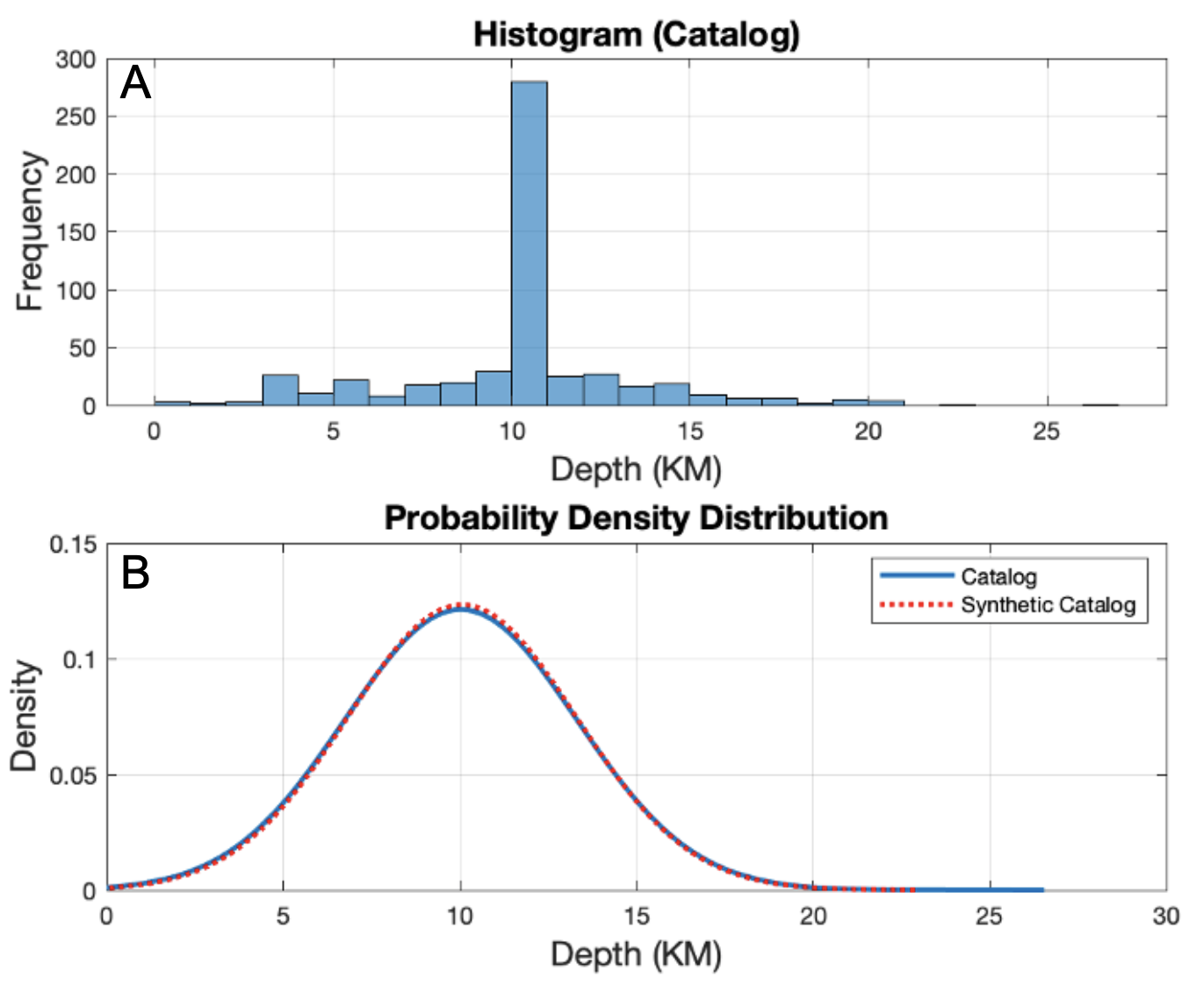

Figure S14. The depth distribution of observed and synthetic seismic records. Figure A presents the relationship between depth distribution and corresponding frequency for the observed background seismicity during the pre-mainshock stage. Figure B displays the probability density distribution of the observed and its synthetic seismicity.

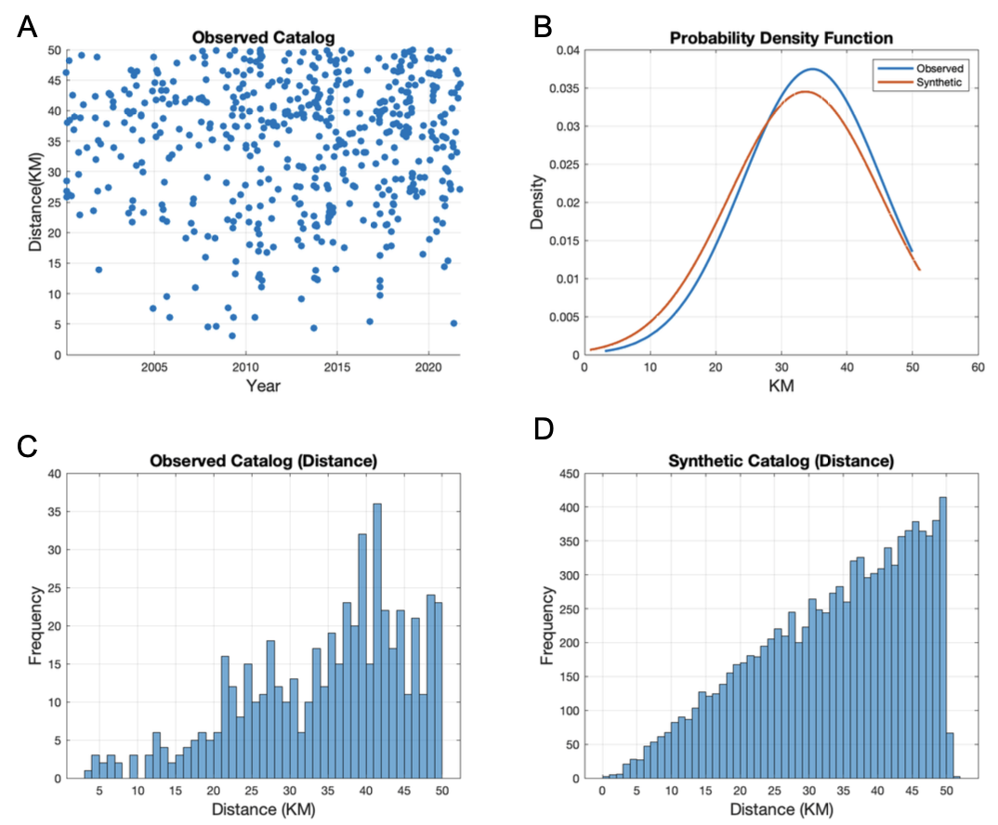

Figure S15. The distance distribution (i.e., from each earthquake's hypocenter to the mainshock's hypocenter) for the observed and synthetic catalogs. Figure A shows the distance distribution for observed background seismicity during the pre-mainshock stage. Figure B presents the distance probability density distribution for both observed and synthetic seismicity. Figures C and D illustrate the distance-frequency relationship for observed background seismicity and synthetic seismicity, respectively.